GROUP PROJECT 2

PHÂN CÔNG
NOTE: đọc những lưu ý quan trọng ở cuối trang trước khi xem công việc được giao. Thân ái
THÔNG

CÔNG VIỆC
Phụ trách (individual):
- Reuse contents trong php: footer, header…
- Enhancement page

Phụ trách (shared responsibility):
- Process_eoi.php: Kiểm tra lại format của toàn bộ table.
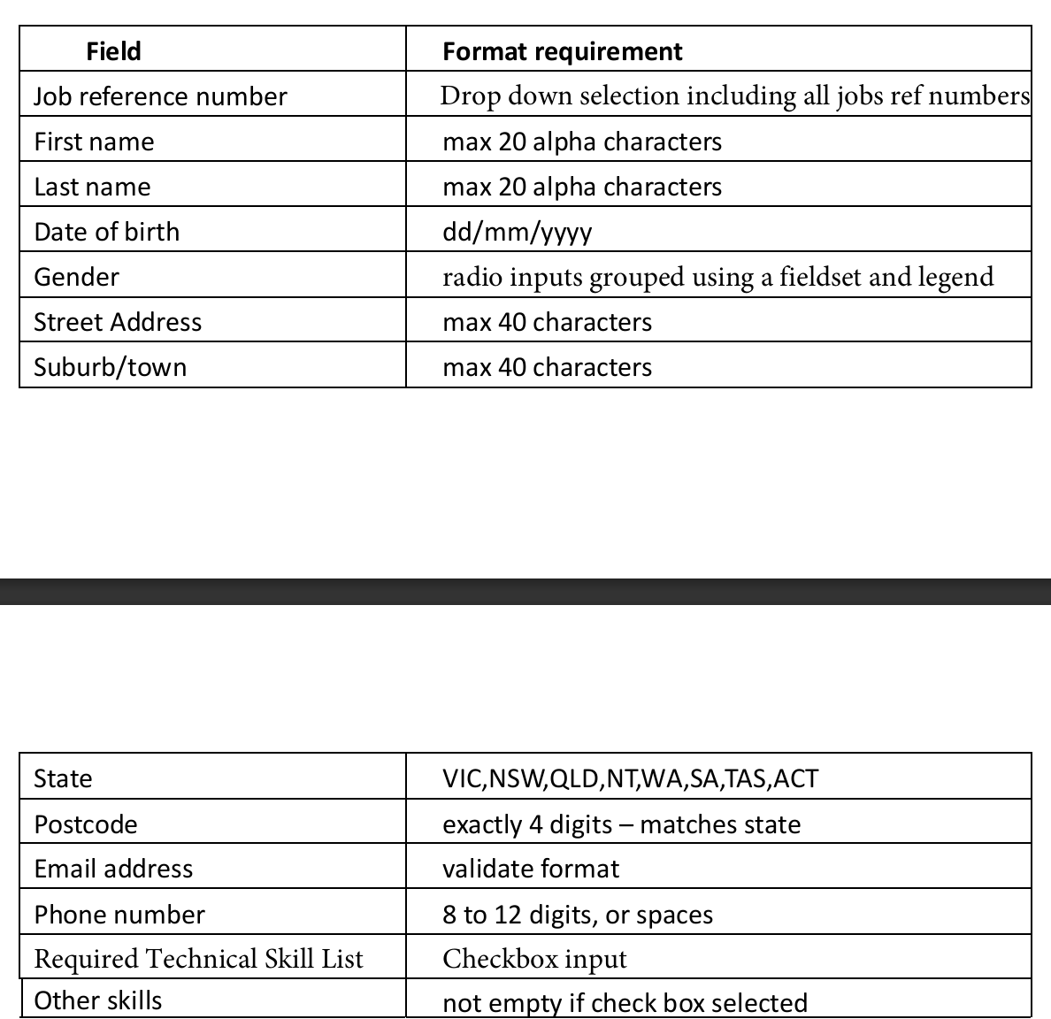
- Setting.php: làm setting.php


HUY

CÔNG VIỆC
Phụ trách (individual):
- Tạo HR manager queries:
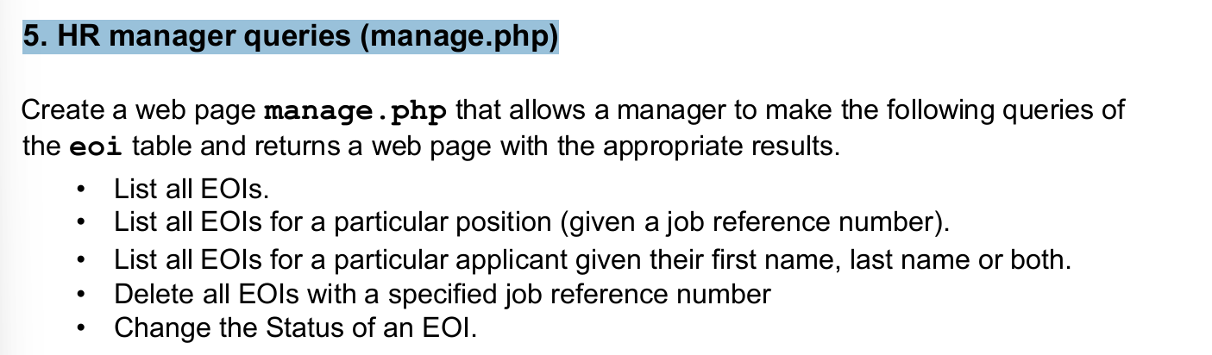
Phụ trách (shared responsibility):
- EOI Table: Kiểm tra lại format của table
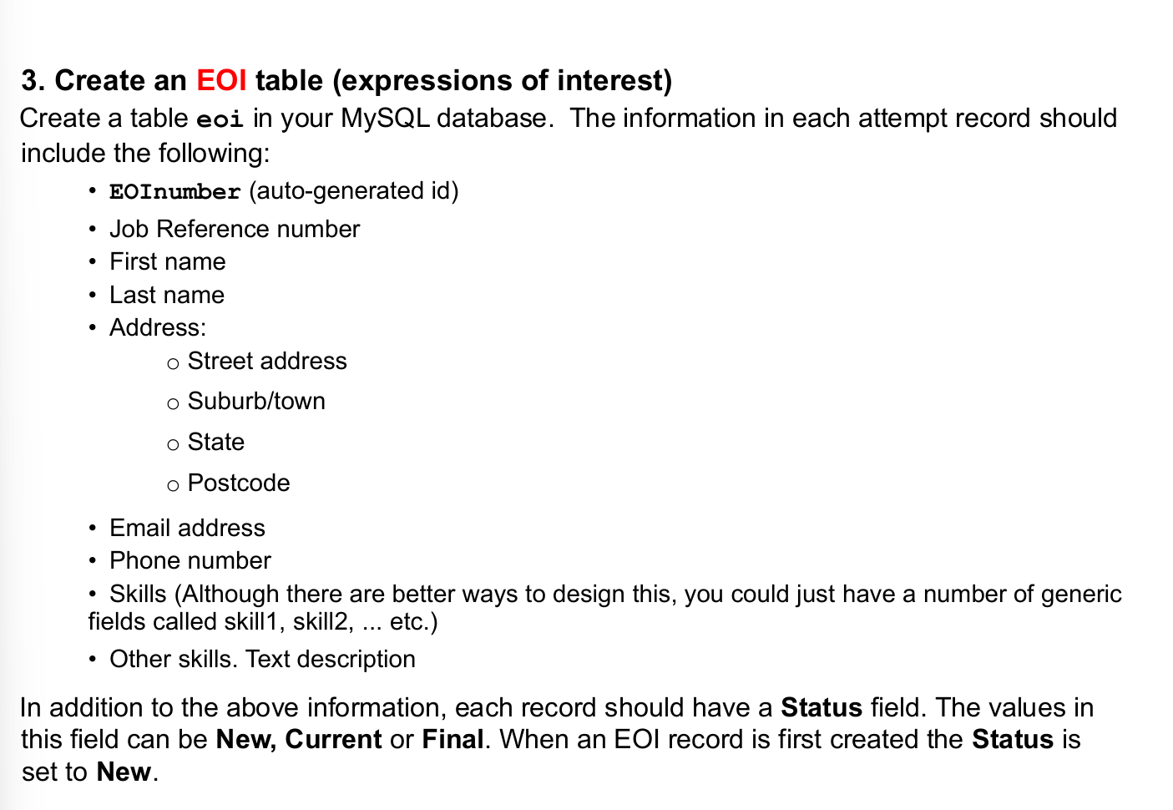
- Setting.php: Kiểm tra lại format của setting.php

ĐAN

CÔNG VIỆC
Phụ trách (individual):
- Update about page (about.php): Update đóng góp của thành viên trong nhóm

Phụ trách (shared responsibility):
- EOI Table: Làm EOI Table


KHANG

CÔNG VIỆC
Phụ trách (individual):
- Tạo Table tên jobs trong MySQl database: Để job description vào database

Phụ trách (shared responsibility):
- Process_eoi.php: làm Process_eoi.php


NHỮNG LƯU Ý QUAN TRỌNG:
MỐC THỜI GIAN:
Duedate: 17/11.
Xong trước: 15/11.
Hoàn Thành Individual responsibility trước ngày 8/11.
Hoàn thành Shared responsibility trước 13/11.
Validate toàn bộ page và final touch cho đến 15/11.
Từ 15/11 – 17/11 sẽ liên tục kiểm tra page để đảm bảo không có bug hay lỗi server.
NOTE CHO EOI TABLE SECTION:

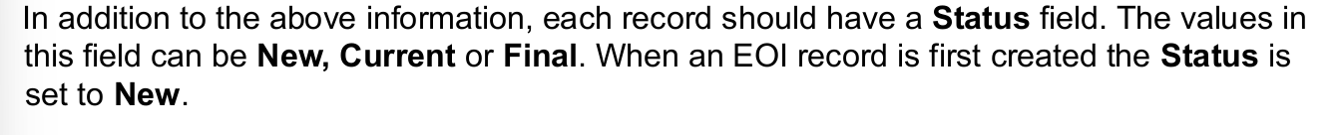

1. Primary key and auto-increment
- The field EOInumber should be the primary key and set to AUTO_INCREMENT so that MySQL automatically generates a unique ID for each record.
2. Data types and field sizes
Choose suitable data types for each field:
- Job Reference number: VARCHAR(10) (if alphanumeric) or INT (if numeric)
- First name / Last name: VARCHAR(50)
- Address fields:
  - Street address: VARCHAR(100)
  - Suburb/town: VARCHAR(50)
  - State: VARCHAR(30)
  - Postcode: VARCHAR(10) (use VARCHAR in case of leading zeros)
- Email address: VARCHAR(100)
- Phone number: VARCHAR(15) (avoid INT because of formatting)
- Skills:
  - Generic skill fields: e.g. skill1 VARCHAR(50), skill2 VARCHAR(50) etc.
  - Other skills (text description): TEXT
- Status: ENUM('New', 'Current', 'Final') DEFAULT 'New'
3. Default values and constraints
- The Status field should default to 'New' when a record is first created.
- You may want to set NOT NULL constraints for mandatory fields such as names and email.
4. Table normalization (for future consideration)
The instruction mentions that having multiple skill1, skill2, etc. columns is not ideal.
A better design would be a separate Skills table with a relationship to the EOI table (many-to-one).
However, for this exercise, you can use the simpler approach suggested.

NOTE CHO PROCESS_EOI.PHP:
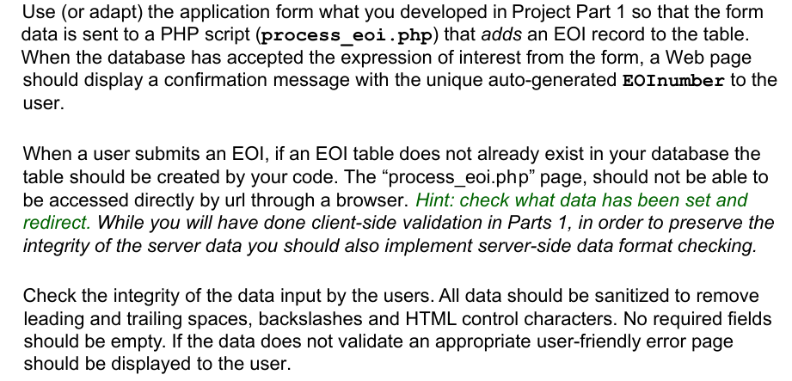
1. Table Creation Check
- The PHP script must check whether the eoi table exists in the MySQL database.
- If it does not exist, your script must create it automatically (using the SQL structure from the earlier step).
2. Data Sanitization and Validation
All inputs must be cleaned and validated on the server side before inserting into the database.
That means:
- Trim whitespace using trim()
- Remove slashes using stripslashes()
- Convert HTML entities with htmlspecialchars()
(to prevent XSS or code injection attacks)
3. Error Handling & User Feedback
- If data fails validation, display a friendly error message (do not show raw PHP or SQL errors).
- If data is successfully inserted, show a confirmation message with the auto-generated EOInumber (from mysqli_insert_id()).
4. Security Notes
- Always use prepared statements (via mysqli_prepare() or PDO) to prevent SQL injection.
- Never rely solely on front-end validation — always recheck everything on the server.
3. Field Format Rules (Critical)
You must enforce these specific constraints before inserting the data:
Field | Requirement / Validation Rule
Job reference number | Must match an existing job reference (from dropdown)
First name | Alphabetic only, ≤ 20 characters
Last name | Alphabetic only, ≤ 20 characters
Date of birth | Must match dd/mm/yyyy format
Gender | Must be one of defined options (radio buttons)
Street address | ≤ 40 characters
Suburb/town | ≤ 40 characters
State | Must be one of: VIC, NSW, QLD, NT, WA, SA, TAS, ACT
Postcode | Must be exactly 4 digits and valid for selected state
Email address | Must be a valid email format (filter_var($email, FILTER_VALIDATE_EMAIL))
Phone number | 8–12 digits or spaces
Required Technical Skill List | Checkbox input (must have at least one selected)
Other skills | Not empty if “Other skills” checkbox is selected

NOTE CHO HR MANAGEMENT:
1. Purpose of manage.php
This page is designed for HR or admin users to query and manage entries in the eoi table.
It should let a manager:
- View all EOIs
- Filter EOIs (by job reference or applicant name)
- Delete EOIs
- Update the Status of an EOI
So it’s essentially a database management interface.

2. Core Functional Requirements
Function | SQL Operation | Description
List all EOIs | SELECT * FROM eoi; | Display all records in an HTML table.
List EOIs for a specific position | SELECT * FROM eoi WHERE job_ref_number = ?; | Use a form input (job ref number) to filter results.
List EOIs for a specific applicant | SELECT * FROM eoi WHERE first_name LIKE ? OR last_name LIKE ?; | Allow partial matches with LIKE.
Delete EOIs for a job reference number | DELETE FROM eoi WHERE job_ref_number = ?; | Use a confirmation step before deleting.
Change EOI status | UPDATE eoi SET status = ? WHERE EOInumber = ?; | Allow dropdown selection (New, Current, Final).

2. Implementation Tips
server-Side Best Practices
- Use prepared statements to prevent SQL injection:
- Sanitize and validate all user inputs using trim(), htmlspecialchars(), etc.
3. Suggested Interface Structure
Your manage.php should include:
- Search / Filter Forms
  - Input for job reference number
  - Input for applicant name
  - Buttons for each operation (Search, Delete, Change Status)
- Results Display
  - Display returned EOIs in a well-formatted HTML table
  - Include EOI number, name, job ref, email, phone, status, etc.
- Status Update Option
  - Each record row could have a dropdown and a submit button for updating its status:
4. Security and Usability Notes
- Restrict this page to authorized users (e.g., use a simple login or session check).
- Confirm deletion actions (e.g., via a confirmation prompt).
- Show meaningful messages after each operation (e.g., “3 EOIs deleted for Job Ref J123”).
5. Optional Enhancements
If allowed by your project scope, you can improve the page by:
- Adding sorting and pagination
- Providing export to CSV
- Including filters for Status (New / Current / Final)

GOALS:
